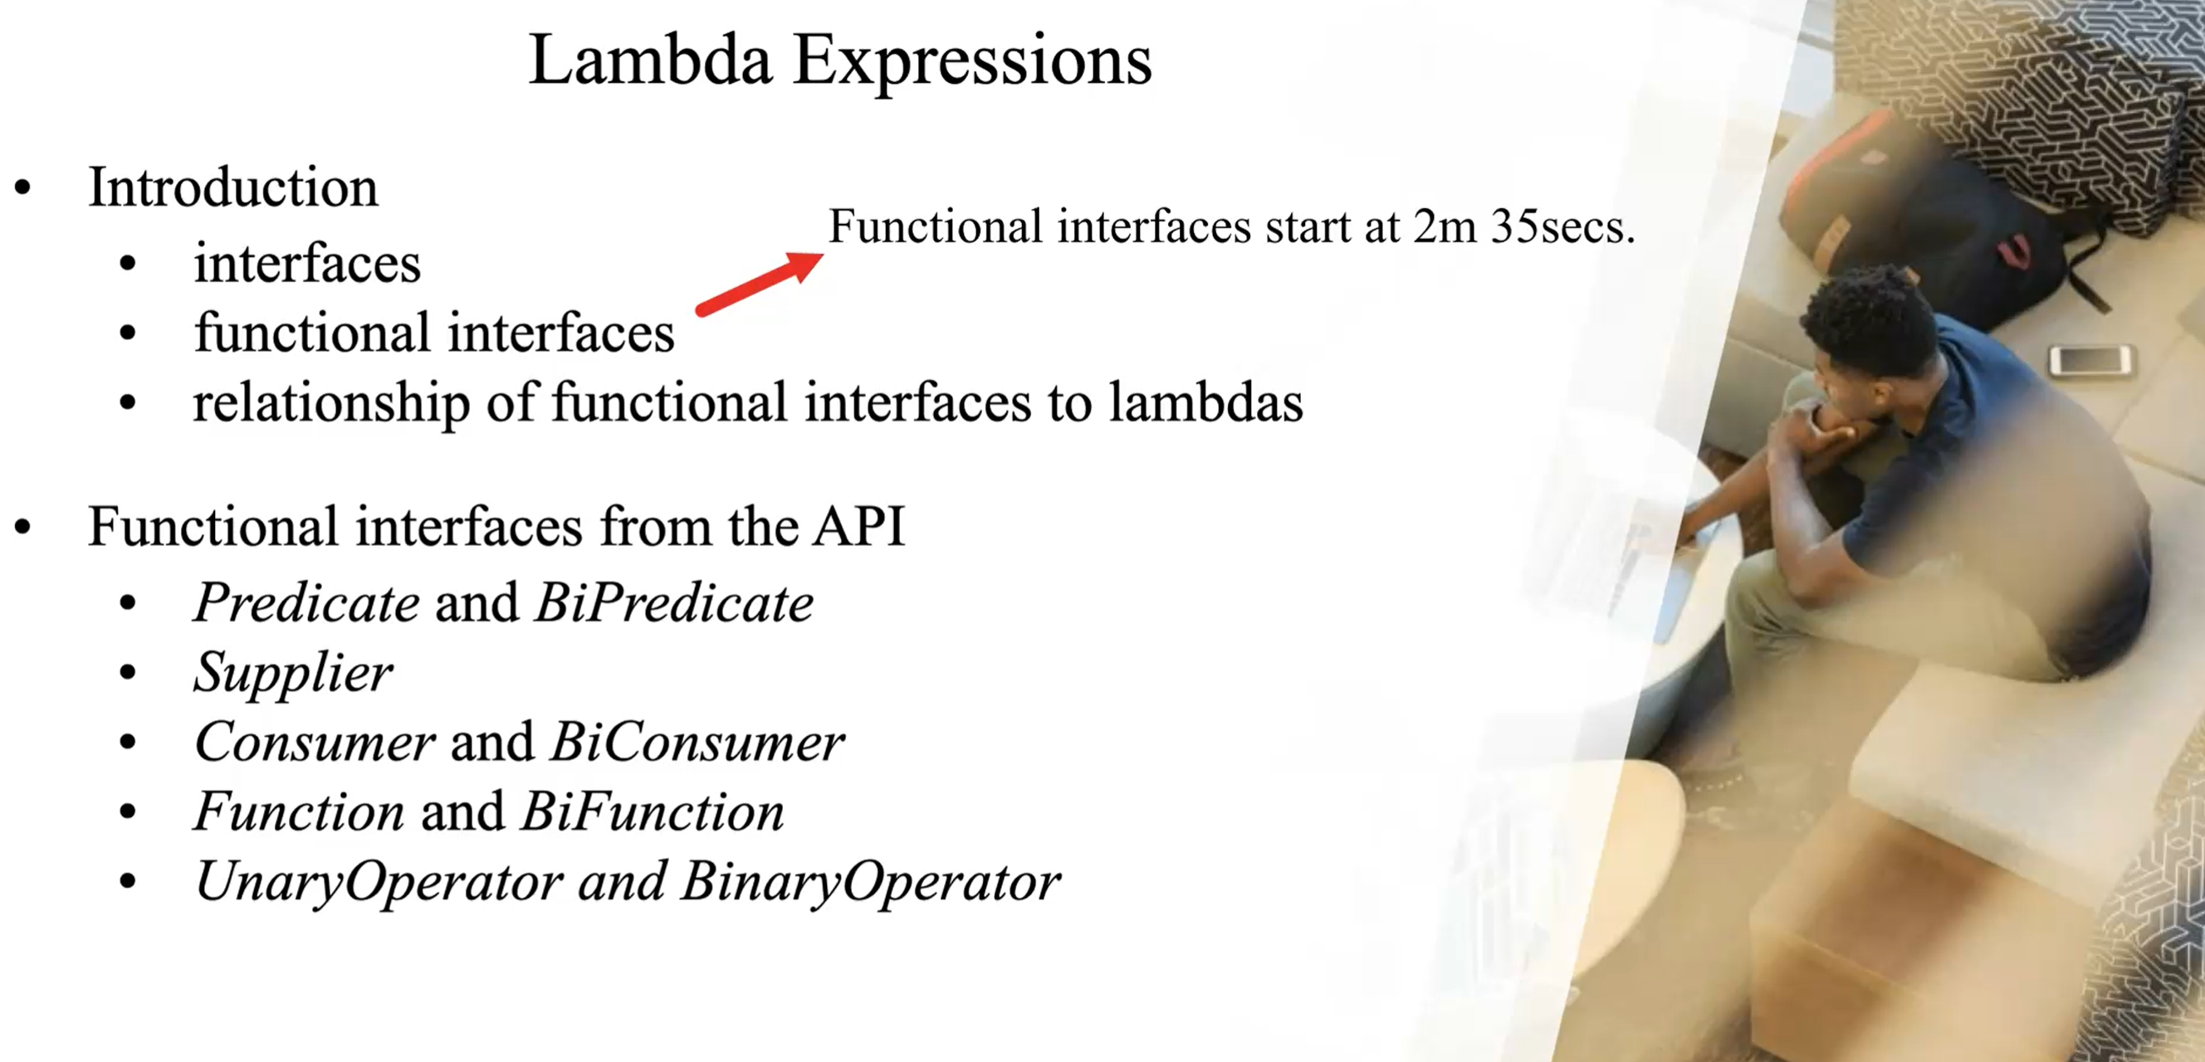

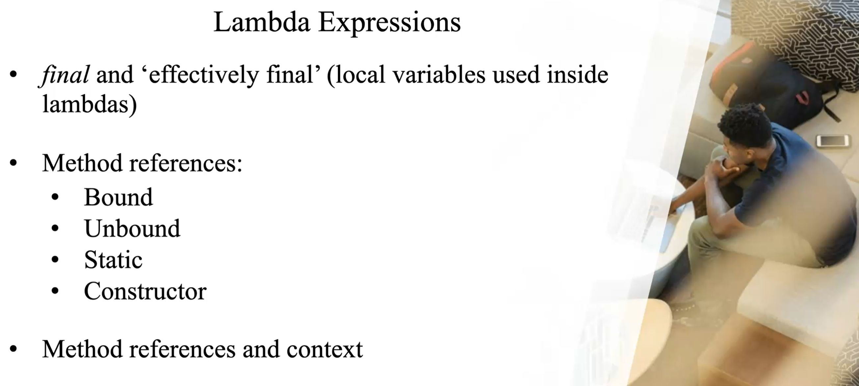

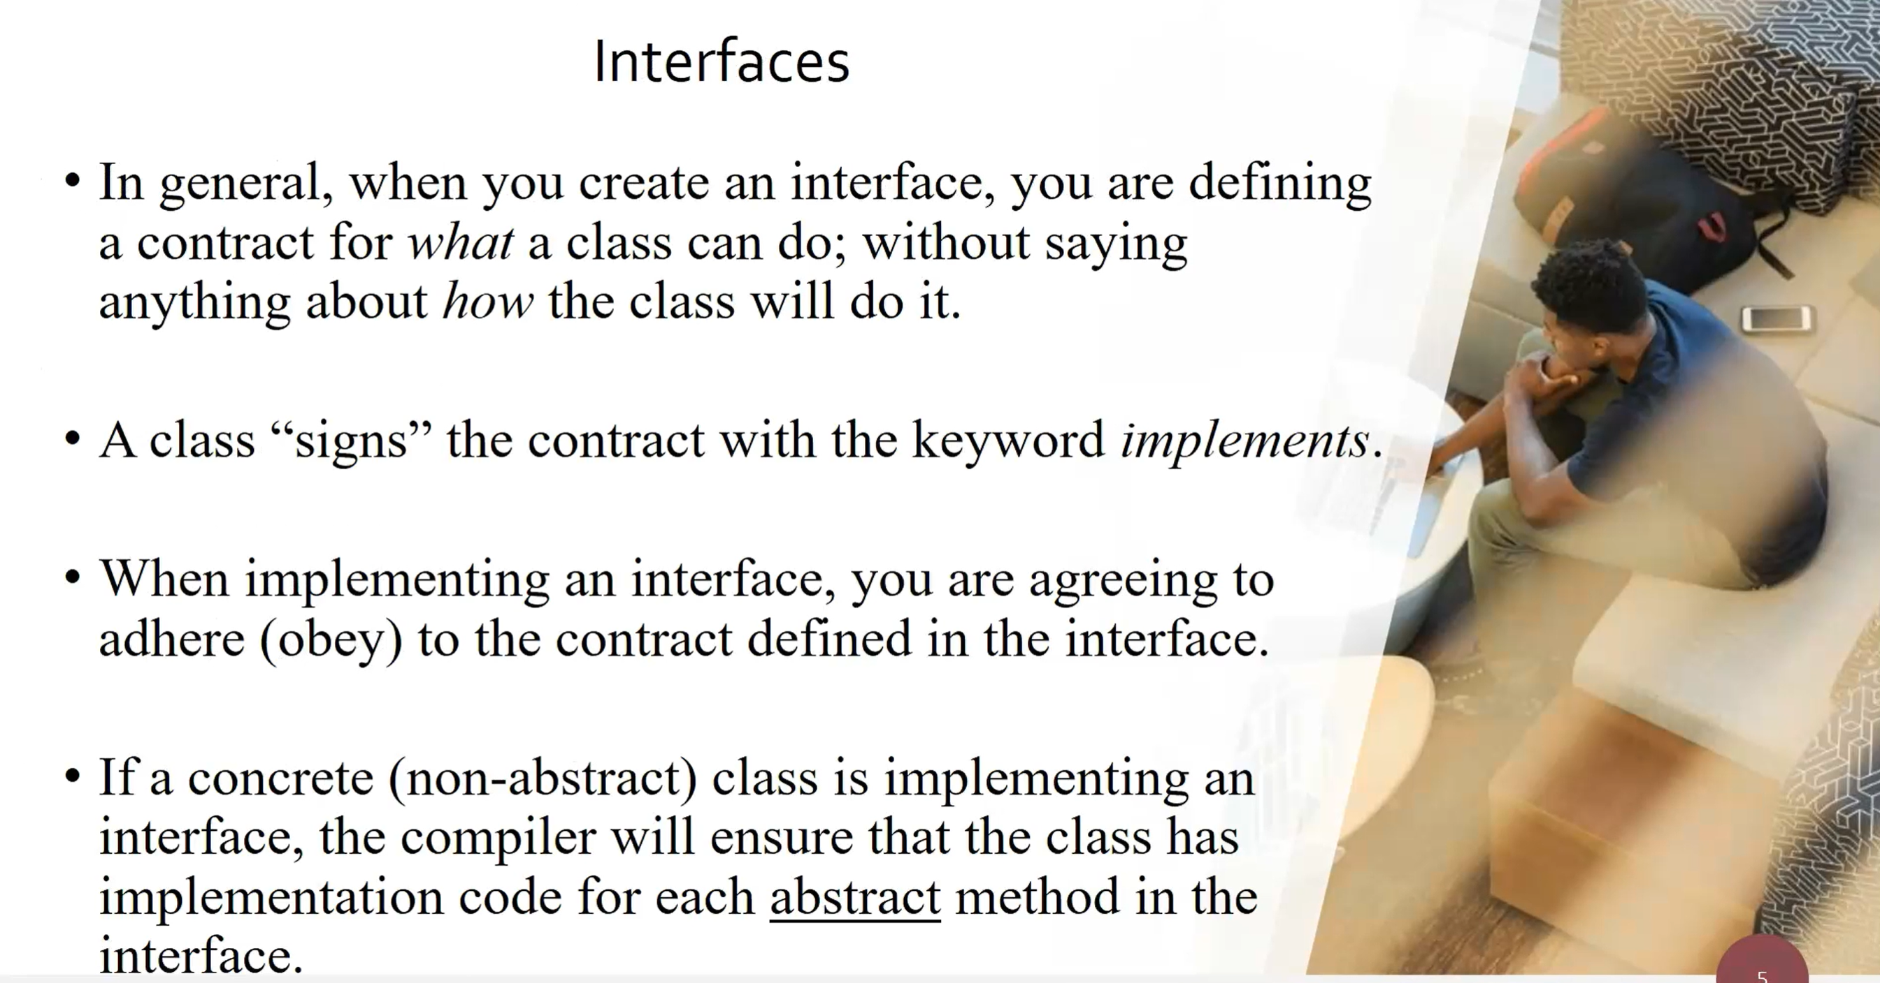

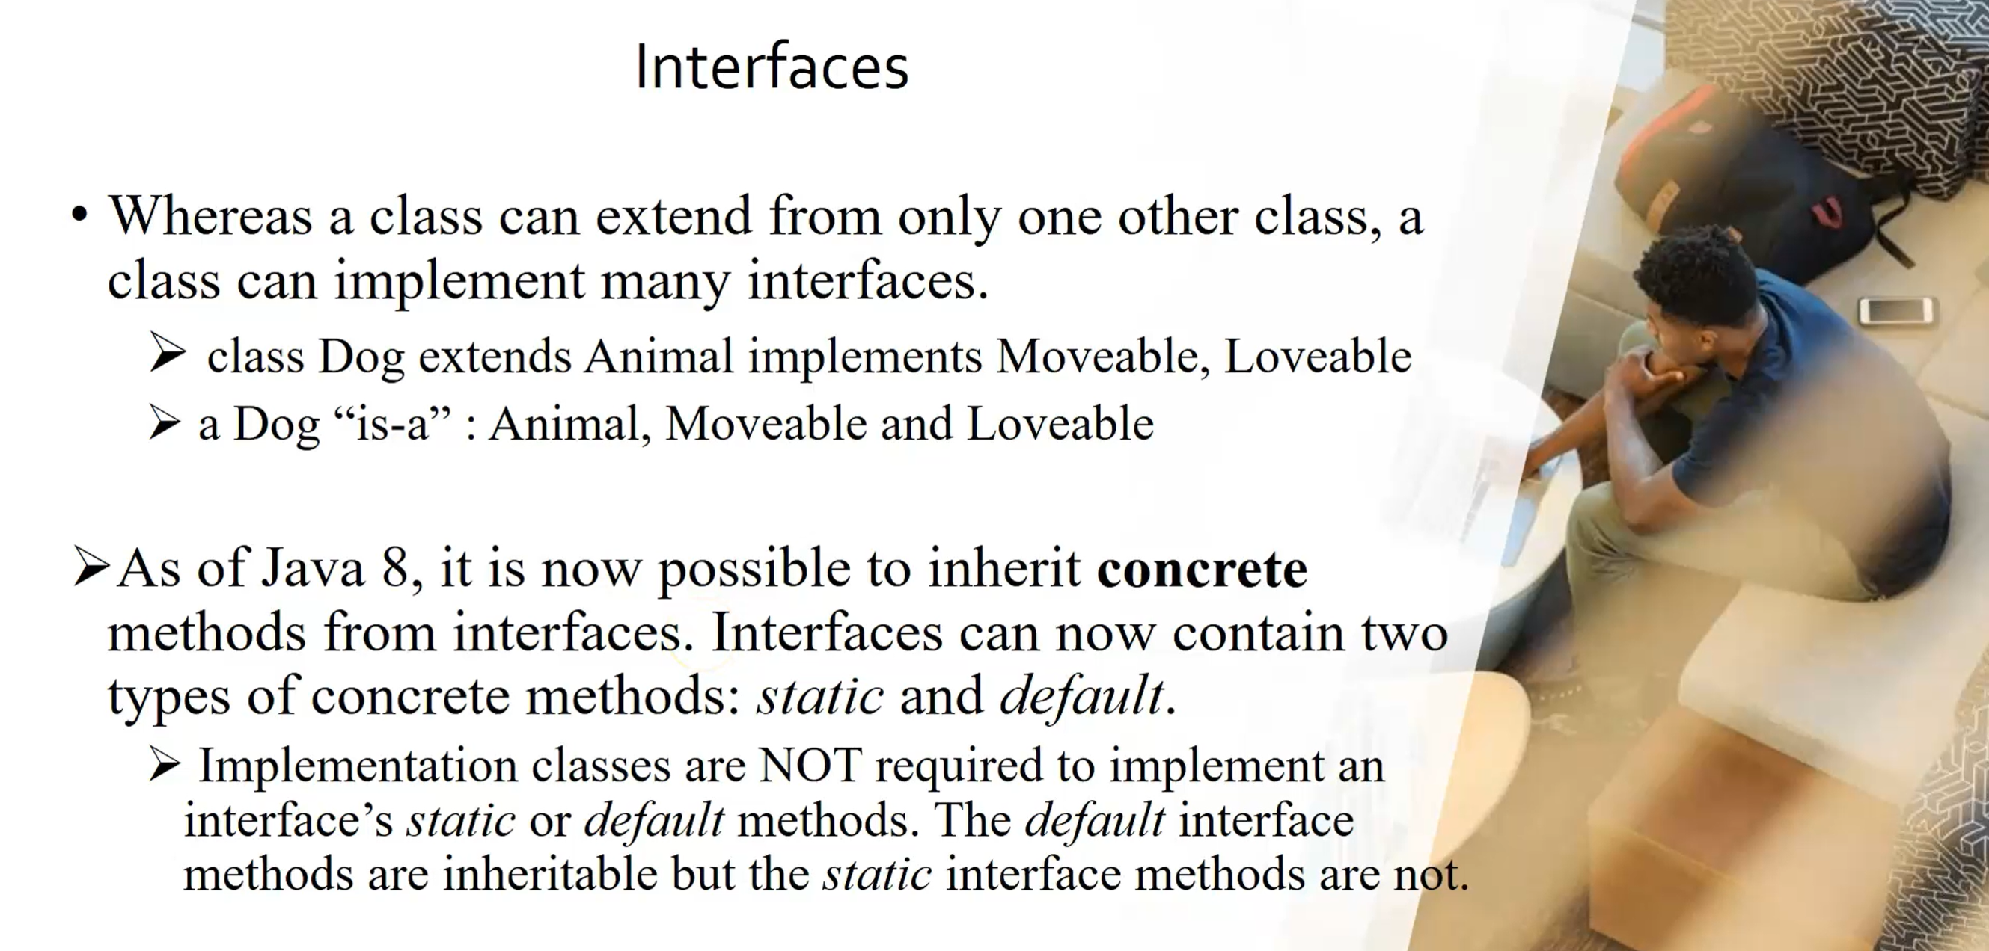

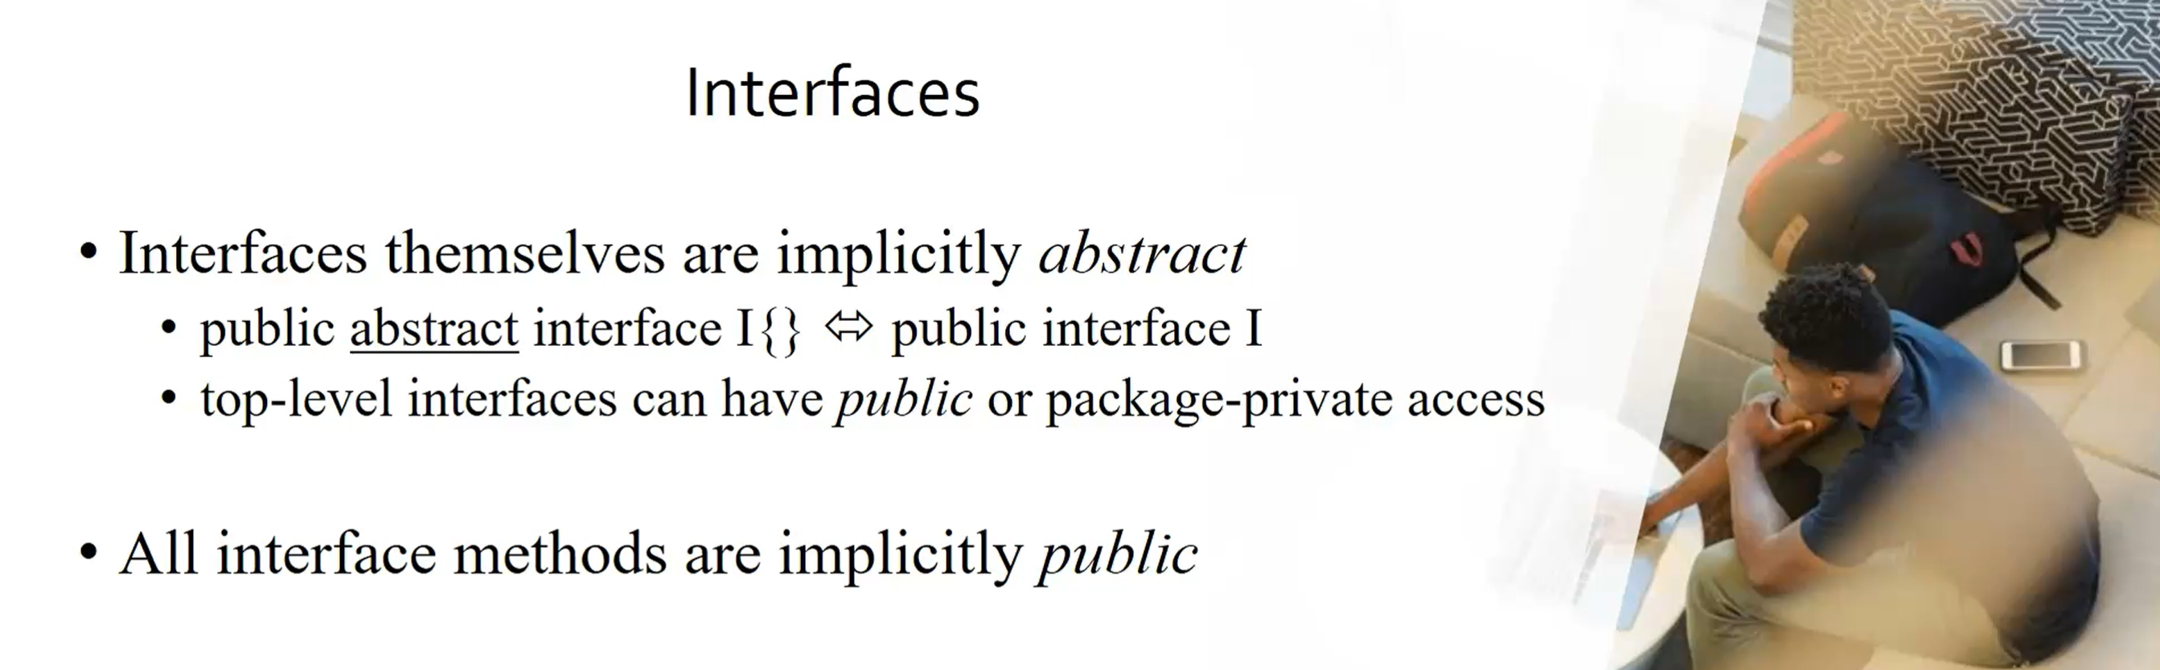

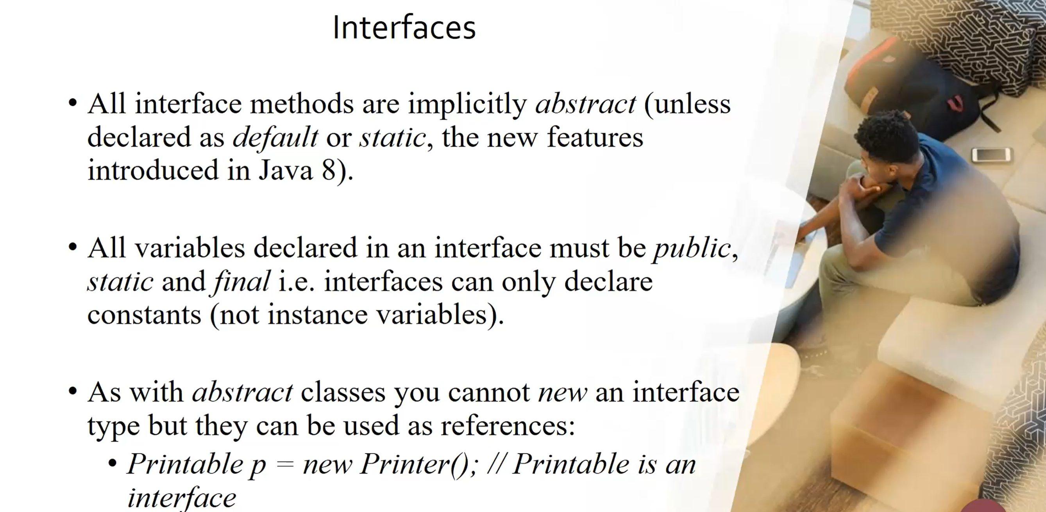

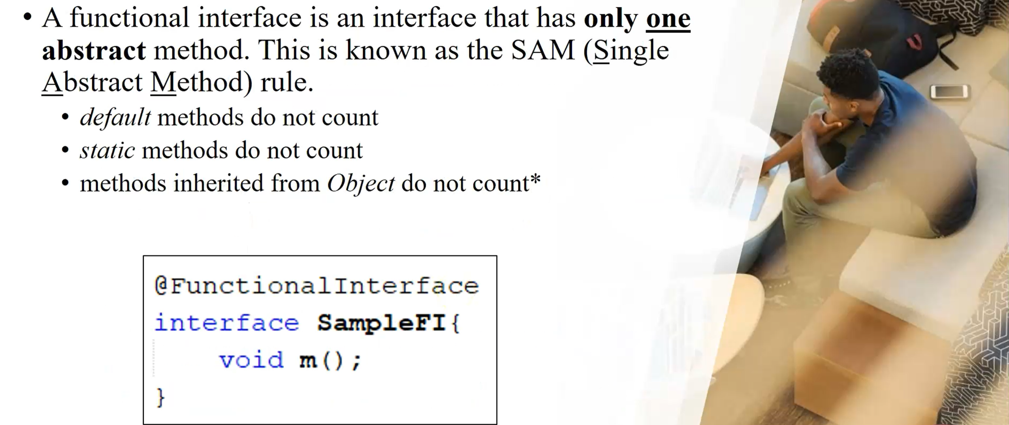

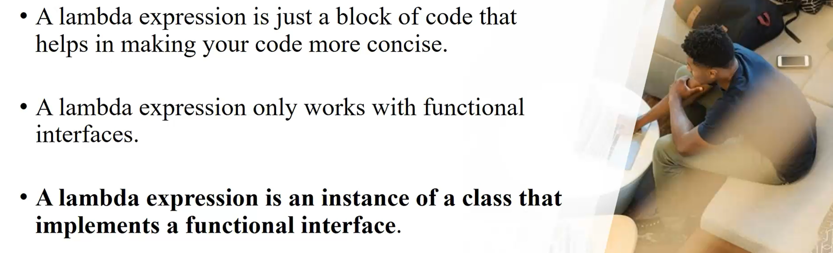

**A LAMBDA EXPRESSION IS AN INSTANCE OF A CLASS THAT IMPLEMENTS A FUNCTIONAL INTERFACE. FUNCTIONAL INTERFACE IS AN INTERFACE WHICH HAVING ONLY ONE ABSTRACT METHOD, HERE DEFAULT AND STATIC METHOD DOES NOT COUNT ALSO METHOD WHICH INHERITAED FROM OBJECT CLASS DOES NOT COUNT.**

